List of Students admitted from other states in to BDS
Year 2016-2017
Sno | Name of the Student | State
1 | B.Manisha | Telangana
2 | S.Amani | Telangana
3 | Nayani sravya | Telangana
4 | A.V.S.Siddhartha | Telangana
5 | A.Nandini Roy | Telangana
6 | R.Kiranmaye | Telangana
7 | K.Sai datta | Telangana
8. | T.sisindri nayak | Telangana
9. | G.Meghana | Telangana
10. | Anil kumar | Telangana

Year 2017-2018
Sno | Name of the Student | State
1 | P.Sai Krishna | Telangana
2 | M.Prabhukiran | Telangana
3 | N.Sai Sannidhi | Telangana
4 | Dantuluri Srujini | Telangana
5 | N.Manasa udaya | Telangana
6 | A.vennela | Maharashtra
7 | Ch.Sairani | Telangana
8 | M.yamini syamalatha | Orissa
9 | K.samyuktha | Telangana
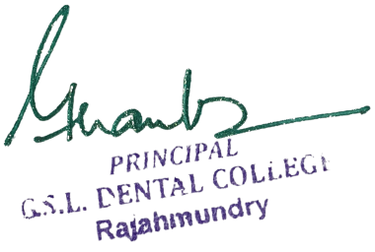

Year 2018-2019
Sno | Name of the Student | State
1 | V.Madhu Kiran | Telangana
2 | V.Srividhya | Delhi
3 | Manisha Nayak | Telangana
4 | Vijaya Lakshmi | Telangana
5 | G.Lalitha prafulla sri | Telangana
6 | D.Haritha | Telangana

Year 2019-2020
Sno | Name of the Student | State
1 | P.Konda Kaushik | Telangana
2 | V.Hemivenkatasri | Telangana
3 | R.harikrishna | Telangana

Year 2020- 2021
Sno | Name of the Student | State
1 | M.prasanna | Telangana
2 | G.Niharaka | Telangana
3 | Aditi dey | West bengal
4 | G.juhitha | Telangana
5 | P.keerthika | Telangana

Year 2021 – 22
Sno | Name of the Student | State
1 | T.Anjanipratap | Telangana
2 | B.Lahyasree | Telangana
3 | K.Sri ratna sravani | UT - Yanam

List of Students admitted from other states in to MDS
Year 2019-20
Sno | Name of the Student | Department | Sate
1 | A.Naga Supraja | Pedodontics | Telangana
2 | P.Pranay Krishna | Oral Medicine and Radiology | Telangana

Year 2020 – 21
Sno | Name of the Student | Department
1 | Damathoti Nihitha | Oral Medicine and Radiology | Telangana

Year 2021 – 22
Sno | Name of the Student | Department | Sate
1 | Solomon prabhu | Conservative dentistry and endodontics | Tamilnadu
2. | Y.Samanvitha | Prosthodontics | Telangana
3. | L.Sri Charitha | Prosthodontics | Telangana
4. | P.Swathi Kiran | Oral and maxilla facial surgery | Telangana
5. | K.Shivani | Pedodontics | Telangana
6. | M.sowmya | Oral pathology | Tamilnadu

